Arica Conrad

BIT 465 – REST API Development

February 27, 2022

Final Project – Web App Design

Catastic Companions – Cat Shelter API

The Cat Shelter API is designed as an internal web service for a cat shelter named Catastic Companions. The employees of the cat shelter can sign up and log in to the system. Once logged in, they can view all the cats they currently have and make changes to the data, such as by adding a new cat, editing the information of an existing cat, or deleting a cat.

Screen Flow

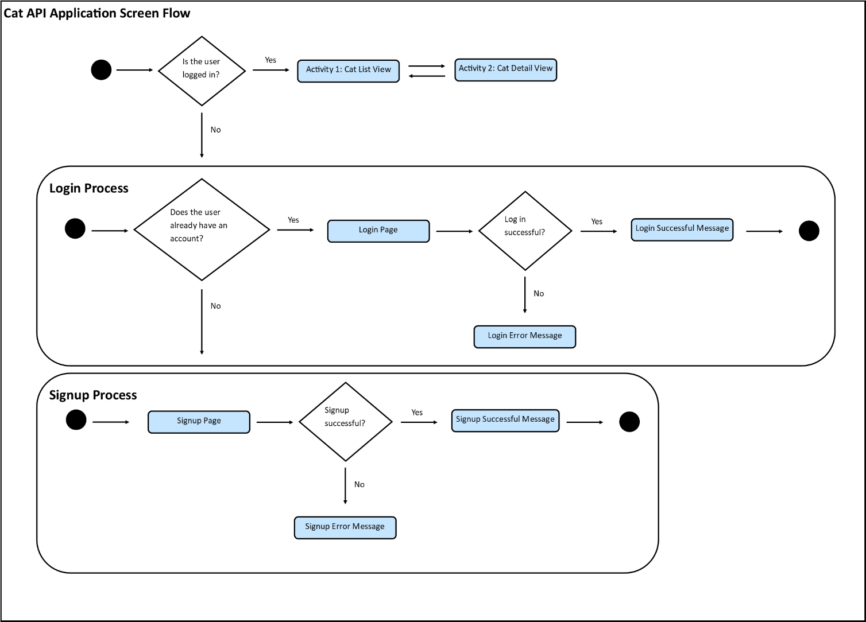

Screens

Activity 1:

This is the page where new users can register and sign up with a username and password to allow them access to the system.

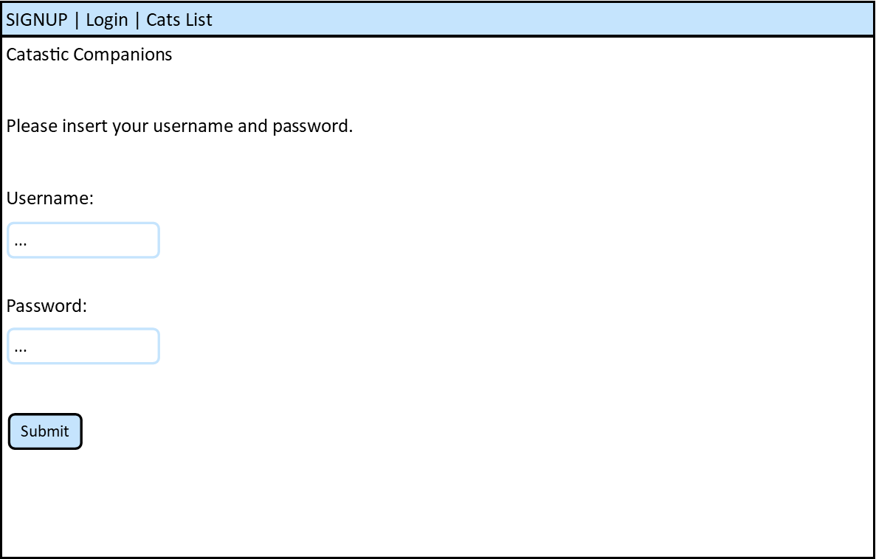

Controls:

Username: The user enters a valid username.

Password: The user enters a valid password.

Submit button: The user presses this button after finishing entering values for the fields above.

Activity 2:

This is the page where returning users can login with the username and password they created before.

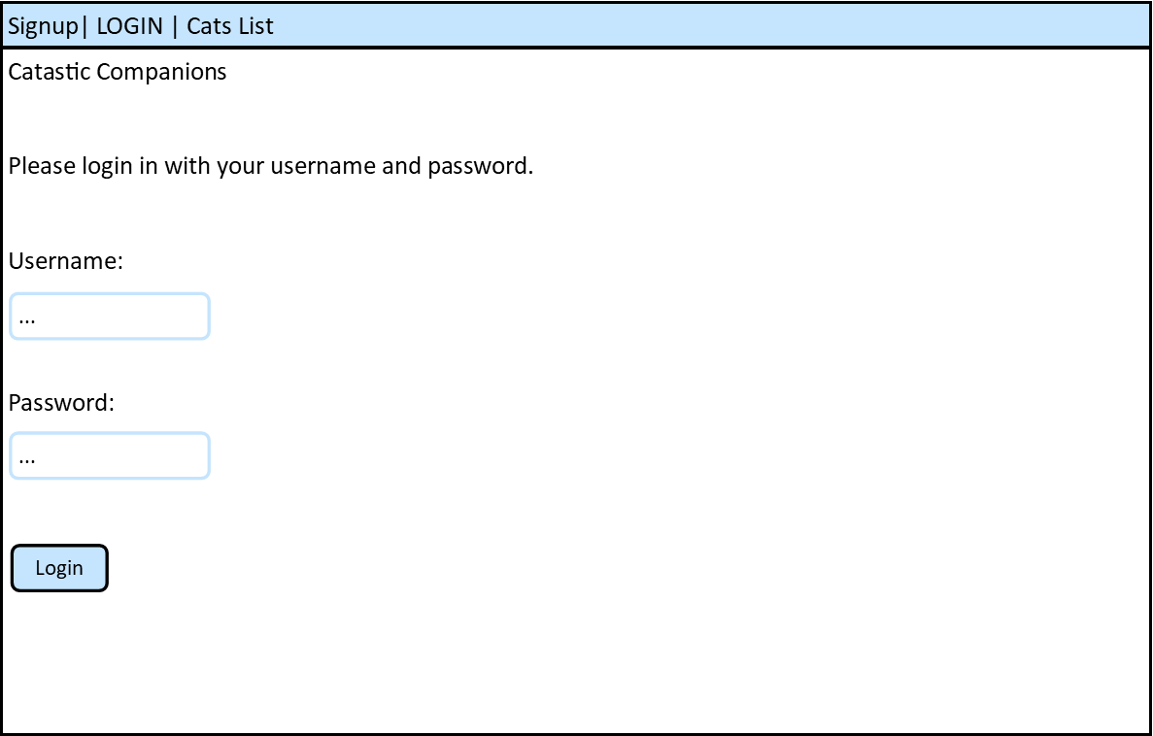

Controls:

Username: The user enters a valid username.

Password: The user enters a valid password.

Login button: The user presses this button after finishing entering values for the fields above.

Activity 3:

This is the page where the users can view all the cats the shelter currently has or has had in the past.

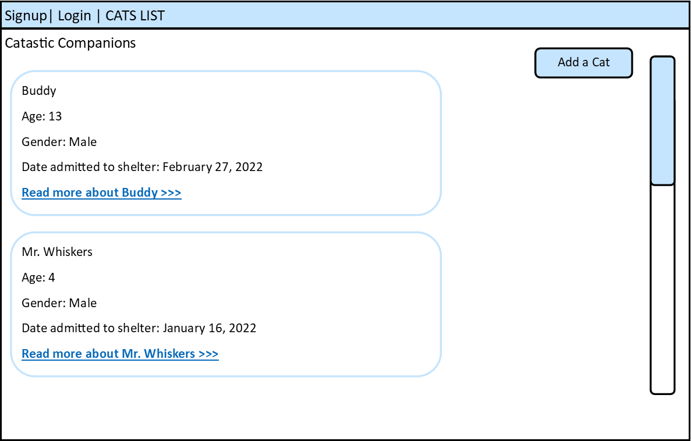

Controls:

“Read More” link: This is a link that the user can press to view more details about an individual cat.

Add a Cat button: This is a button that the users can press to add a cat to the database if a new cat has come to the shelter.

Activity 4:

This is the page where the users can view the details of one specific cat in particular.

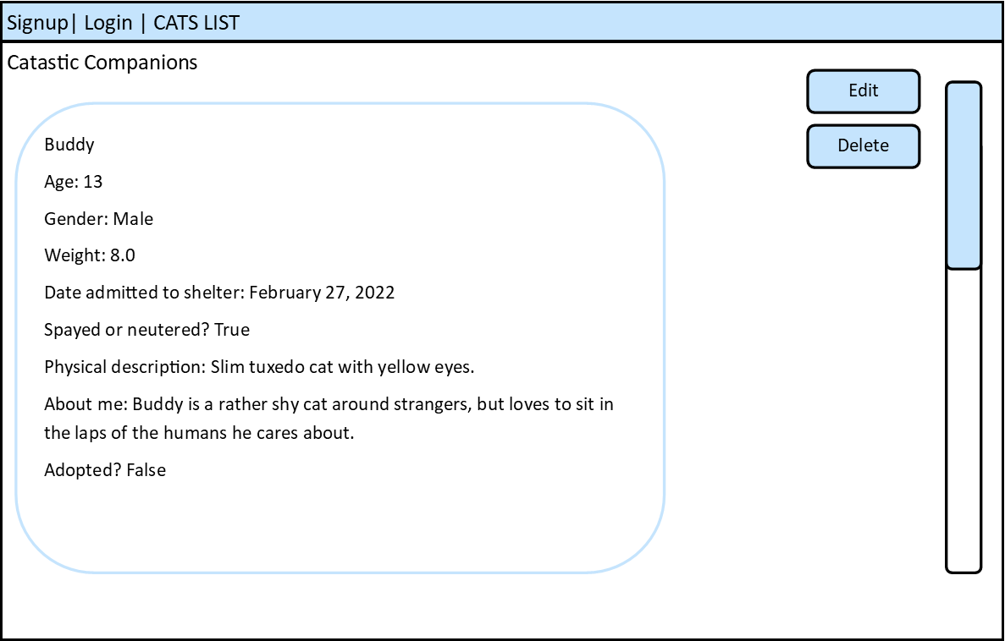

Controls:

Edit button: This is a button that the users can press to edit the details of the cat they are currently on.

Delete button: This is a button that the users can press to delete the cat they are currently on, such as if the cat has left the shelter.

Activity 5:

This is the template for the page where the users can add a cat or edit the details of one specific cat.

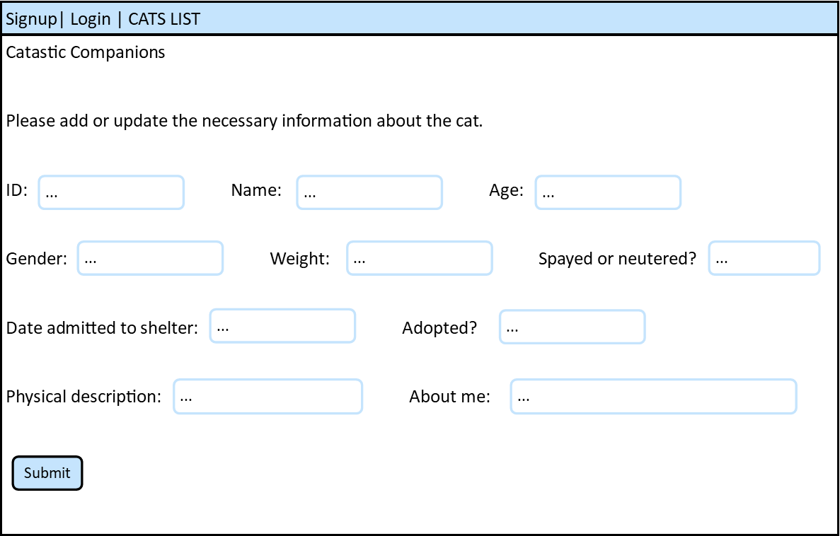

Controls:

Text fields for all the columns: All the text fields allow the user to enter or update the necessary information about the cat.

Submit button: The user presses this button after finishing entering values for the fields above.

Data Schema

Users table:

This stores the login and signup information of the cat shelter employees. I was unsure if the primary key should be separate from the username, so I create a separate field as the primary key.

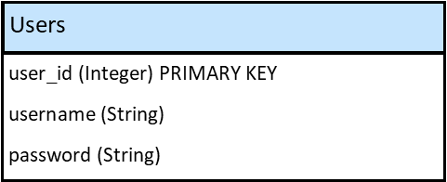

Sample records:

[{ “user_id”: 1, “username”: “Arica Conrad”, “password”: “12345” },

{ “user_id”: 2, “username”: “Cheryl Conrad”, “password”: “54321” }]

Cats table:

This stores the information about the cats in the shelter. There is an is_adopted field for cats who were previously at the shelter but have now been adopted. Since this application is for internal use only, it would be helpful for staff members to know which cats have been adopted. If I have time, I also ideally would like to have a field that stores the weblink to an image of the cat (maybe using S3 to host the images).

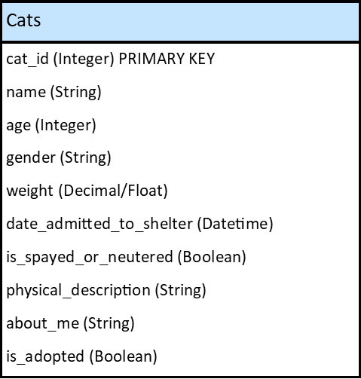

Sample records:

[{ “cat_id”: 1, “name”: “Buddy”, “age”: 13, “gender”: “Male”, “weight”: 8.5, “date_admitted_to_shelter”: “2022-02-27”, “is_spayed_or_neutered”: true, “physical_description”: “Thin, tuxedo, yellow eyes.”, “about_me”: “Buddy is a shy cat, but is friendly when he warms up to you.”, “is_adopted”: true },

{ “cat_id”: 2, “name”: “Ginger”, “age”: 5, “gender”: “Female”, “weight”: 10.0, “date_admitted_to_shelter”: “2022-02-28”, “is_spayed_or_neutered”: true, “physical_description”: “Small dilute ginger with blue eyes.”, “about_me”: “Ginger is a friendly cat who loves to play with toys.”, “is_adopted”: false }]

Summary

Though my templates above are rudimentary in design, I strive to have clean and clear pages. According to WebFX, the goal of a mobile web design’s layout, “…Is to allow the least amount of burden to the user’s ability to find and quickly read information.” The pages will have a logical flow between them, and tabs and headings will show the users where they are at all times. The text fields and buttons will be clearly marked and can be easily interacted with. I will make sure the final product has good color contrast, a reasonable font size, and that information is presented in a concise way. All of this will make for a pleasing user experience.

Reference: [Mobile Web Design: Best Practices - WebFX](https://www.webfx.com/blog/web-design/mobile-web-design-best-practices/)